Wood Projects

2000: Dining room table. 102” by 42” inches. Made from Brazilian cherry. Clear poly stain.

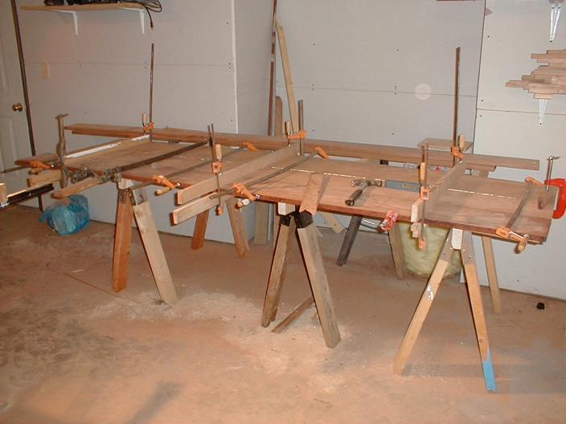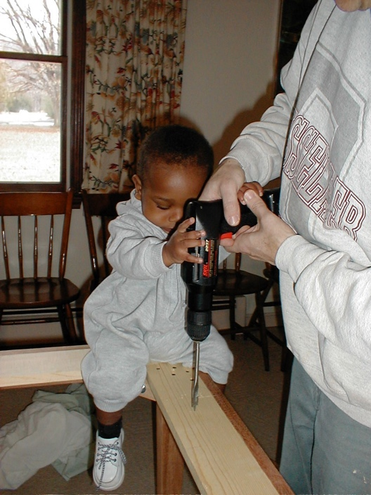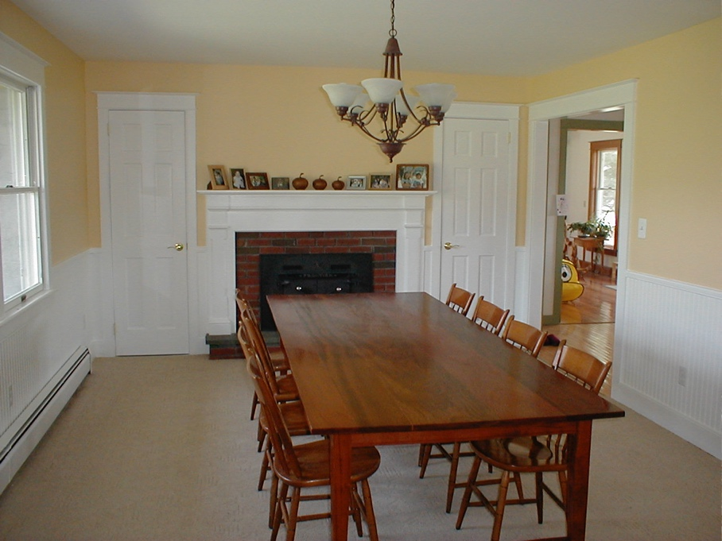

2020 July – pine spice rack for Emily.

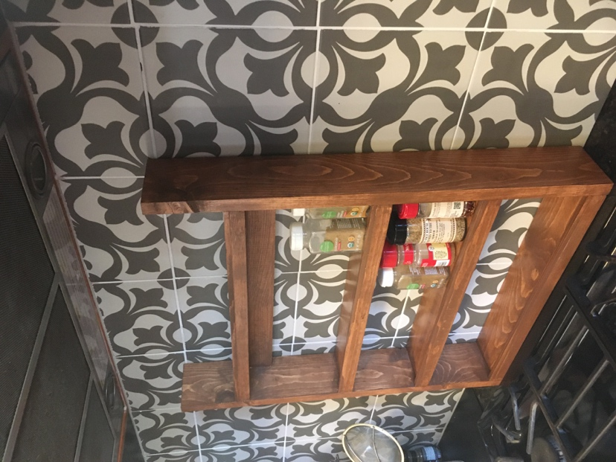

2001 Bookshelves. Pine sides and shelving (painted) with Brazilian cherry trim.

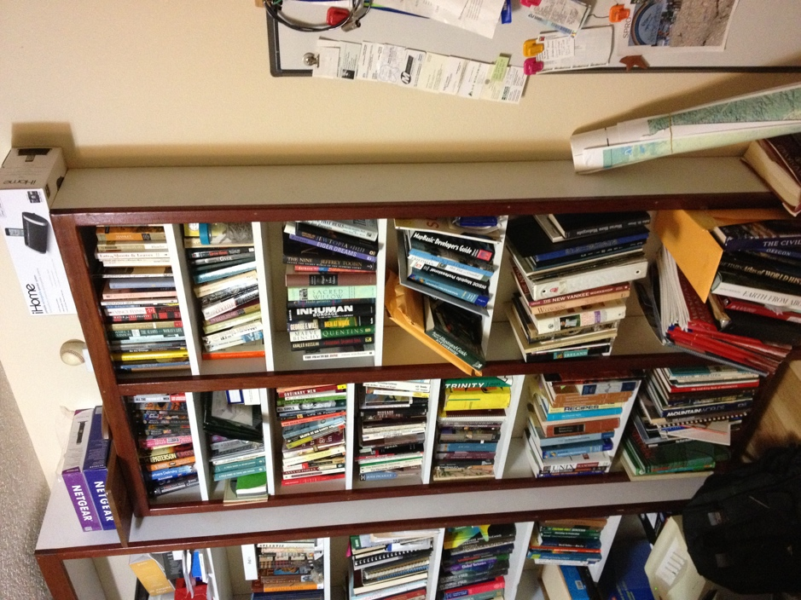

2011 Oak and walnut bookshelves.

